**NAMA : EKA KURNIAWAN AGUSTYAS KOMSTYADI**

**NBI : 1462200171**

**CODE**

#include <iostream>

#include <conio.h>

using namespace std;

void maximal(){

int angka, jumlah, max ;

cout <<"\n===== Program Pencari Nilai Maksimum =====";

cout << "\nBerapa banyak angka yang ingin di komparasi ?";

cout <<endl;

cin >> jumlah;

for (int i=1; i<=jumlah; i++){

cout <<"\nMasukan Angka ";

cin >> angka;

if(i==1){

max = angka;

}

else if (max < angka){

max = angka;

}

}

cout <<"\nAngka terbesar adalah "<< max <<endl;

cout <<"=============================================="<<endl;

}

void minimal(){

int angka, jumlah, min ;

cout <<"\n===== Program Pencari Nilai Minimal =====";

cout << "\nBerapa banyak angka yang ingin di komparasi ?";

cout <<endl;

cin >> jumlah;

for (int i=1; i<=jumlah; i++){

cout <<"\nMasukan Angka ";

cin >> angka;

if(i==1){

min = angka;

}

else if (min > angka){

min = angka;

}

}

cout <<"\nAngka terkecil adalah "<< min <<endl;

cout <<"=============================================="<<endl;

}

void conver (){

int nilai;

string hasil;

cout << "===== Program Konversi Nilai ke Angka =====" << endl;

cout << "\nMasukan Nilai : ";

cin >> nilai;

if (nilai >= 95 && nilai <= 100)

{

hasil = "A+";

}

else if (nilai >= 90 && nilai <= 94) {

hasil= "A";

}

else if (nilai >= 85 && nilai <= 89) {

hasil= "A-";

}

else if (nilai >= 80 && nilai <= 84) {

hasil= "B+";

}

else if (nilai >= 75 && nilai <= 79) {

hasil= "B";

}

else if (nilai >= 70 && nilai <= 74) {

hasil= "B-";

}

else if (nilai >= 65 && nilai <= 69) {

hasil= "C+";

}

else if (nilai >= 60 && nilai <= 64) {

hasil= "C";

}

else if (nilai >= 55 && nilai <= 59) {

hasil= "C-";

}

else if (nilai >= 30 && nilai <= 54) {

hasil= "D";

}

else if (nilai >= 0 && nilai <= 29) {

hasil= "E";

}

cout << "Nilai Angka : "<< hasil <<endl;

cout <<"=============================================="<<endl;

}

int main() {

int pil; bool stop;

stop = false ;

while(!stop){

cout << "Menu " << endl;

cout << "1. Maximal " << endl;

cout << "2. Minimal " << endl;

cout << "3. Conversi " << endl;

cout << "4. Exit " <<endl;

cout << "pilih menu "; cin>> pil;

switch(pil){

case 1: maximal();break;

case 2: minimal(); break;

case 3: conver(); break;

case 4: stop=true; break;

}

}

}

**OUTPUT**

**PROGRAM MENCARI ANGKA MAKSIMAL**

**PROGRAM MENCARI ANGKA MINIMAL**

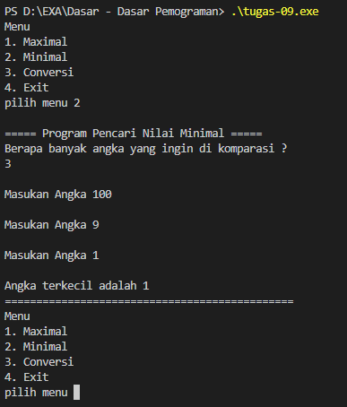

**PROGRAM KONVERSI ANGKA**

